**Adventures with My New Friend Della from December 5, 2015 to June 9, 2016**

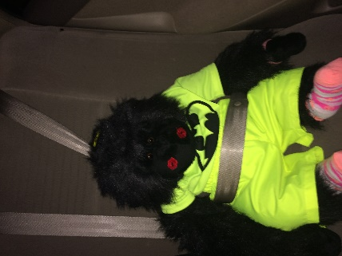On December 5, 2015 I met my new friend, Della. She told me when we left church that everyone in her car had to wear a seatbelt. I told her that I don’t remember if I had ever used a seatbelt before and would she take a picture for my book “The Life of Rupert”. I think that I look really cute with the seatbelt on!

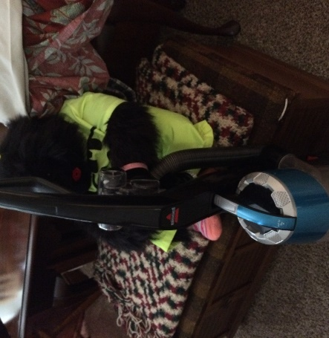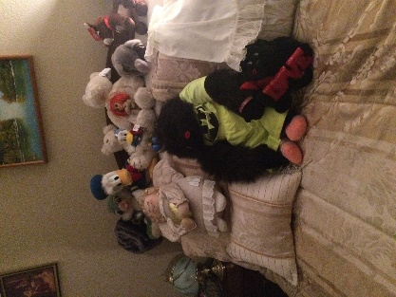On the way to her home she told me that although I would be making new friends and want to play with the other animals at her home that I had to do my part in keeping the house clean. While she dusted the furniture I was responsible for vacuuming the carpet. I was so proud of how the carpet looked once I finished. After we finished we celebrated with ice cream.

While I was visiting with Della she told me that since it was the Christmas Season that we would have a lot of things to do. That we would be going shopping, attending Christmas parties and practicing the music for the Midnight Mass on Christmas Eve.

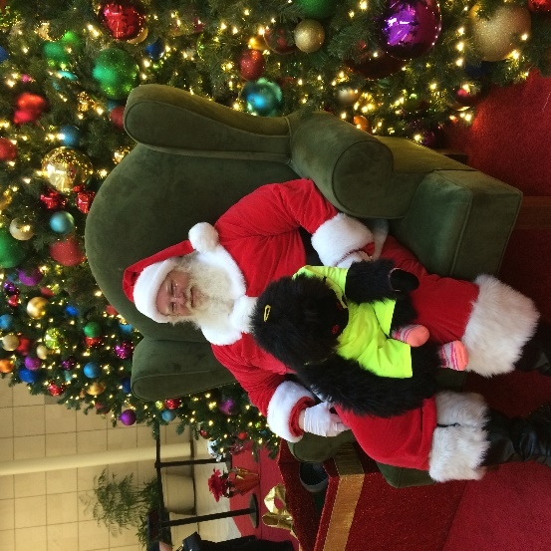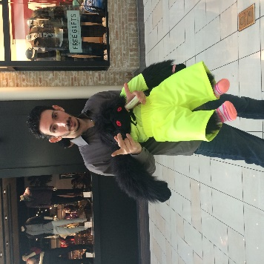Since we were going shopping I was hoping that I might visit with Santa. To my surprise that was the first place we headed to at the Mall. On the way to visit Santa I met a really nice guy by the name of Rafael. We had a really nice chat. My visit with Santa was wonderful. We talked and talked and talked!

I was not able to go to the choir practice. I played with my friends when I should have helped with the vacuuming. I was grounded. 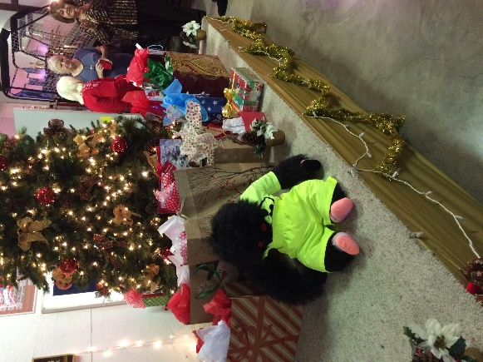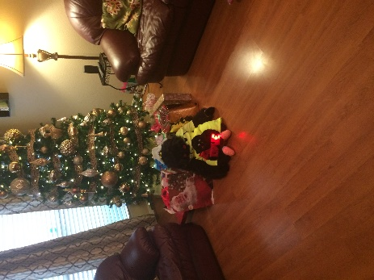Closer to Christmas Della and I went to the Choir’s Christmas Party. We had so much fun! I wanted a picture of myself in front of the Christmas tree. We played a game where people were able to select a present under the tree or steal from someone else. I was concerned because you are not supposed to steal but everyone said that it was okay because it was just a game. As we played the game I began to understand what they were saying. It was almost as if it was more fun when people did steal. I will always remember the game. We also went to the 25 Years Club Christmas Party at Anheuser Bush. There was lot of food and we played the same game. I guess in this case it is okay to steal!

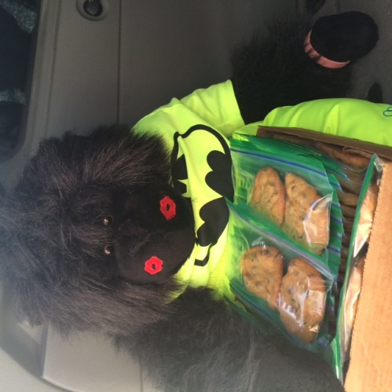Aggie, a friend of Della’s, asked if we could make cookies for the Fish Fry at church during the Lent Season. I asked Della if I could help. She said that it would be great. We were going to make Chocolate Chip Cookies. It was a lot of fun making the cookies with Della. On Friday we took the cookies to church. I am going to have to remember how she made the cookies because they tasted so good!!

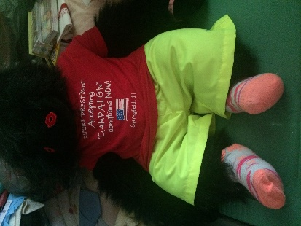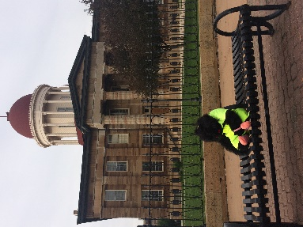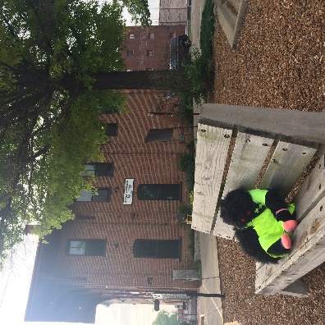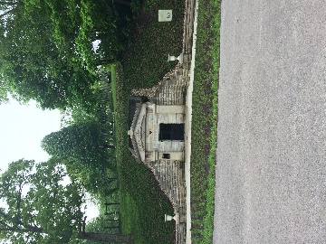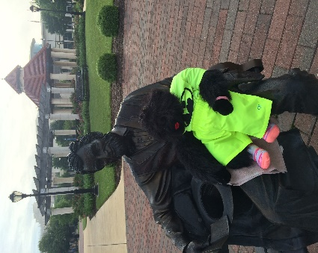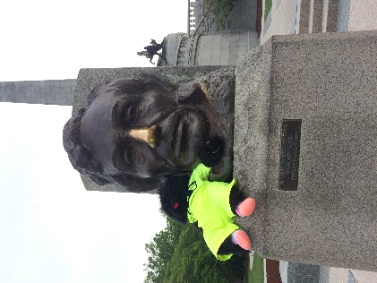Last month John, Della and I went to Springfield, IL. While we were there I was able to visit the Lincoln Memorial. For good luck I rubbed his nose. Just down the hill from the Lincoln Memorial is the original crypt were President Lincoln was placed until the Lincoln Memorial was completed. Across the street from the Lincoln Museum there is a park. Throughout the park there are benches with a sculptor of President Lincoln. I was able to sit on his lap. Near the park is the Old State Capitol. Della explained that the train depot near the park is not the original train depot that President Elect Lincoln left Springfield to go to Washington, DC. She took me to the original train depot. I got a new shirt.

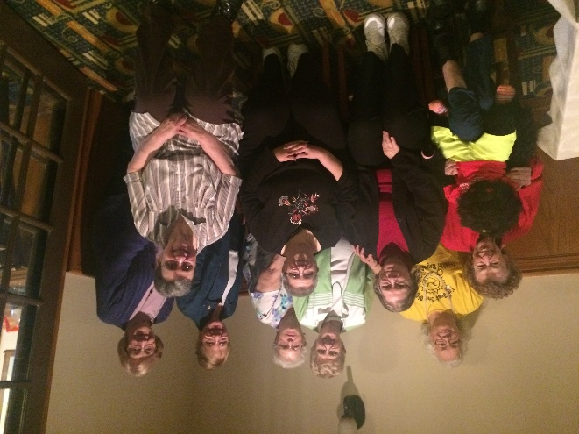When Della lived in Springfield she meet some ladies who live in West Chicago. They became good friends so while we were in the area we went up to West Chicago and had dinner with them. I sat next to Ellie and we had a wonderful talk. She let me play with her cane.

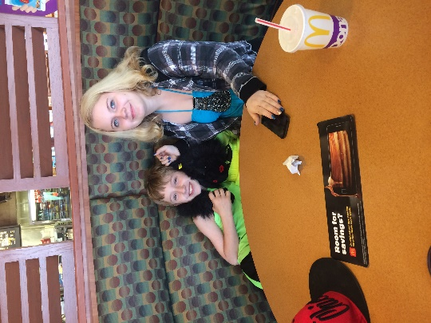While we were in Springfield I got to meet Amber and Jeffery, Della’s niece and nephew. We went to McDonalds and celebrate Amber’s Birthday. She turned 16 on May 14th. After that we went to White Oaks Mall and went shopping. Along with a gift she received some money. With the money she bought a couple of more present. We had a lot of fun at the Mall.

I have enjoyed my time with Della and know that I have made a lifelong friend.